Air Source Heat Pump
What is the function of an air source heat pump?
An air source heat pump, sometimes referred to as an air-to-water source heat pump, transfers heat from the outside air to water, which heats your rooms via radiators or underfloor heating. It can also heat water stored in a hot water cylinder for your hot taps, showers, and baths.
Benefits
Lower Electricity Bills.
Reduce your carbon footprint.
Easy installation process.
Can be used for heating and cooling.
Low maintenance and long-life span.

Disadvantages
Can be noisy.
Your home must already be well insulated.
Lower heat supply than traditional boilers.

How much space is required to install an ASHP?
You’ll need a place outside your home where a unit can be fitted to a wall or placed on the ground. It must have some space around it to allow a good flow of air. This system also requires a cylinder internally, if there is no airing cupboard to house this one may need to be created within the home.

What is the installation process and how will this impact me?

Access required for 5 working days to complete work sequence.
Disruption to heating/hot water for up to 2 days.

Work Sequence

Initial builders work to install concrete slab to hold unit externally – 1 day.
Removal of existing heating system, install pipework, cylinder, and radiators – 2 days.
Electrician to wire up and commission system – 1 day.
Remedial works – 1 day.

When will I see the benefits of this?

Residents have noticed the financial benefits usually 6 months – 1 year of the system being installed.
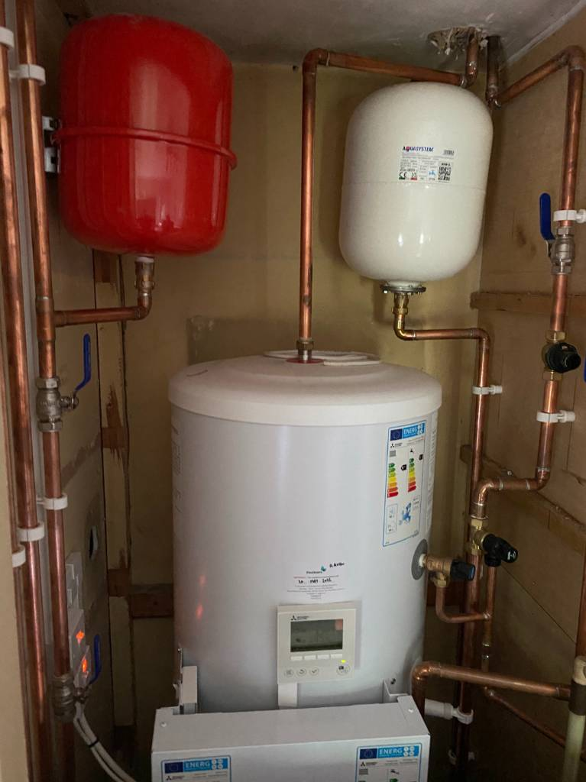

External ASHP unit

Internal Cylinder

